AWS Project
Implementation of Website Hosting on AWS with a Custom VPC,Application Load Balancer,Auto Scaling,CloudWatch Monitoring,SNS Alerting,and Isolated Private Database

1.Web Server with Load Balancer DNS and EC2 Instances
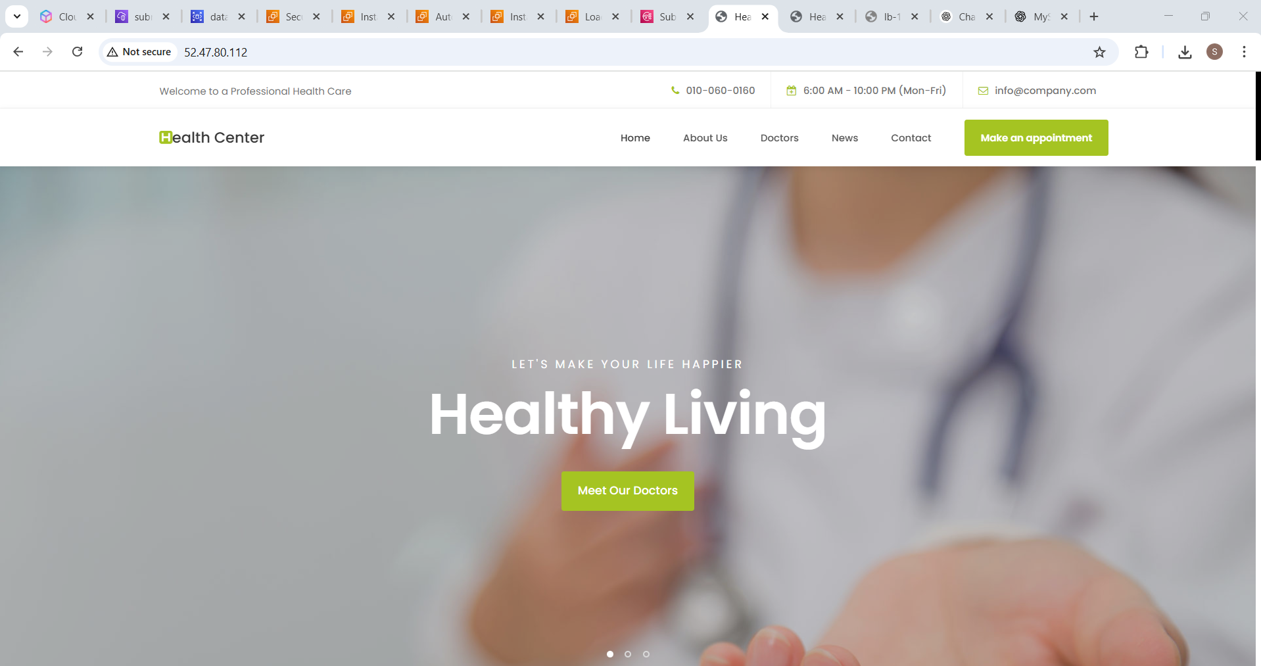

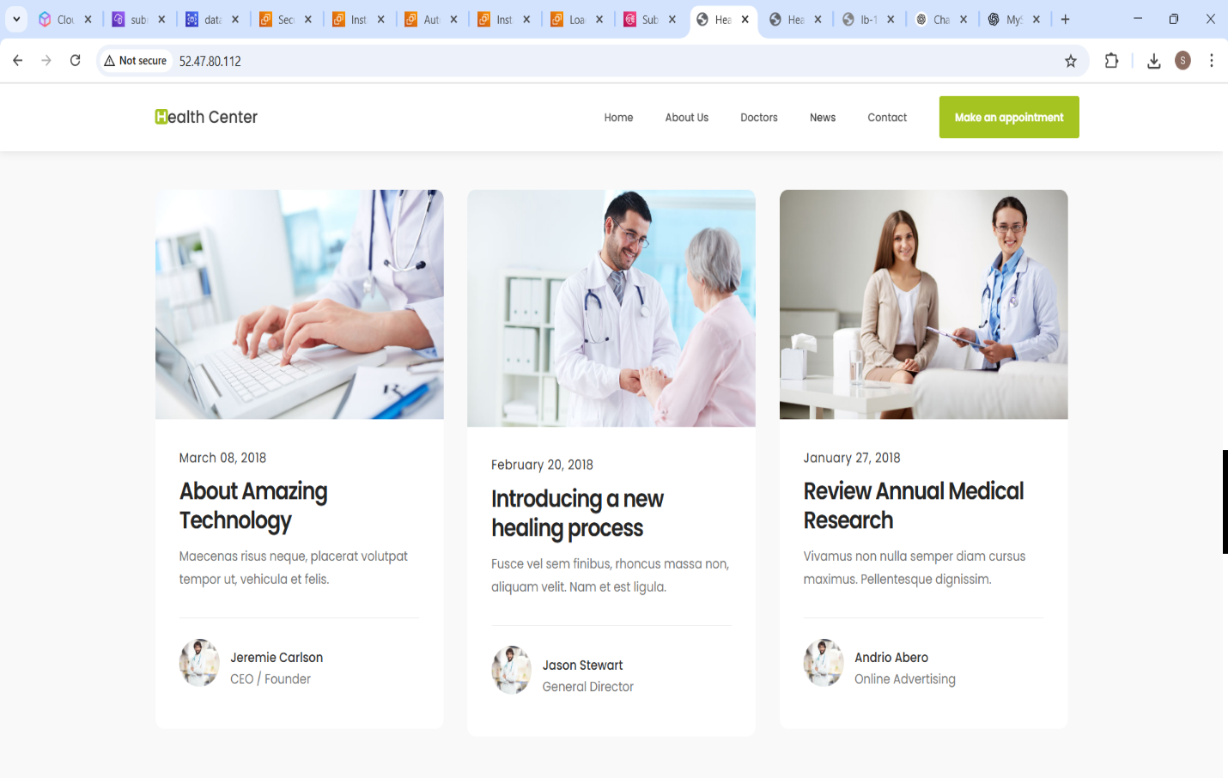

2.Create VPC and Subnet
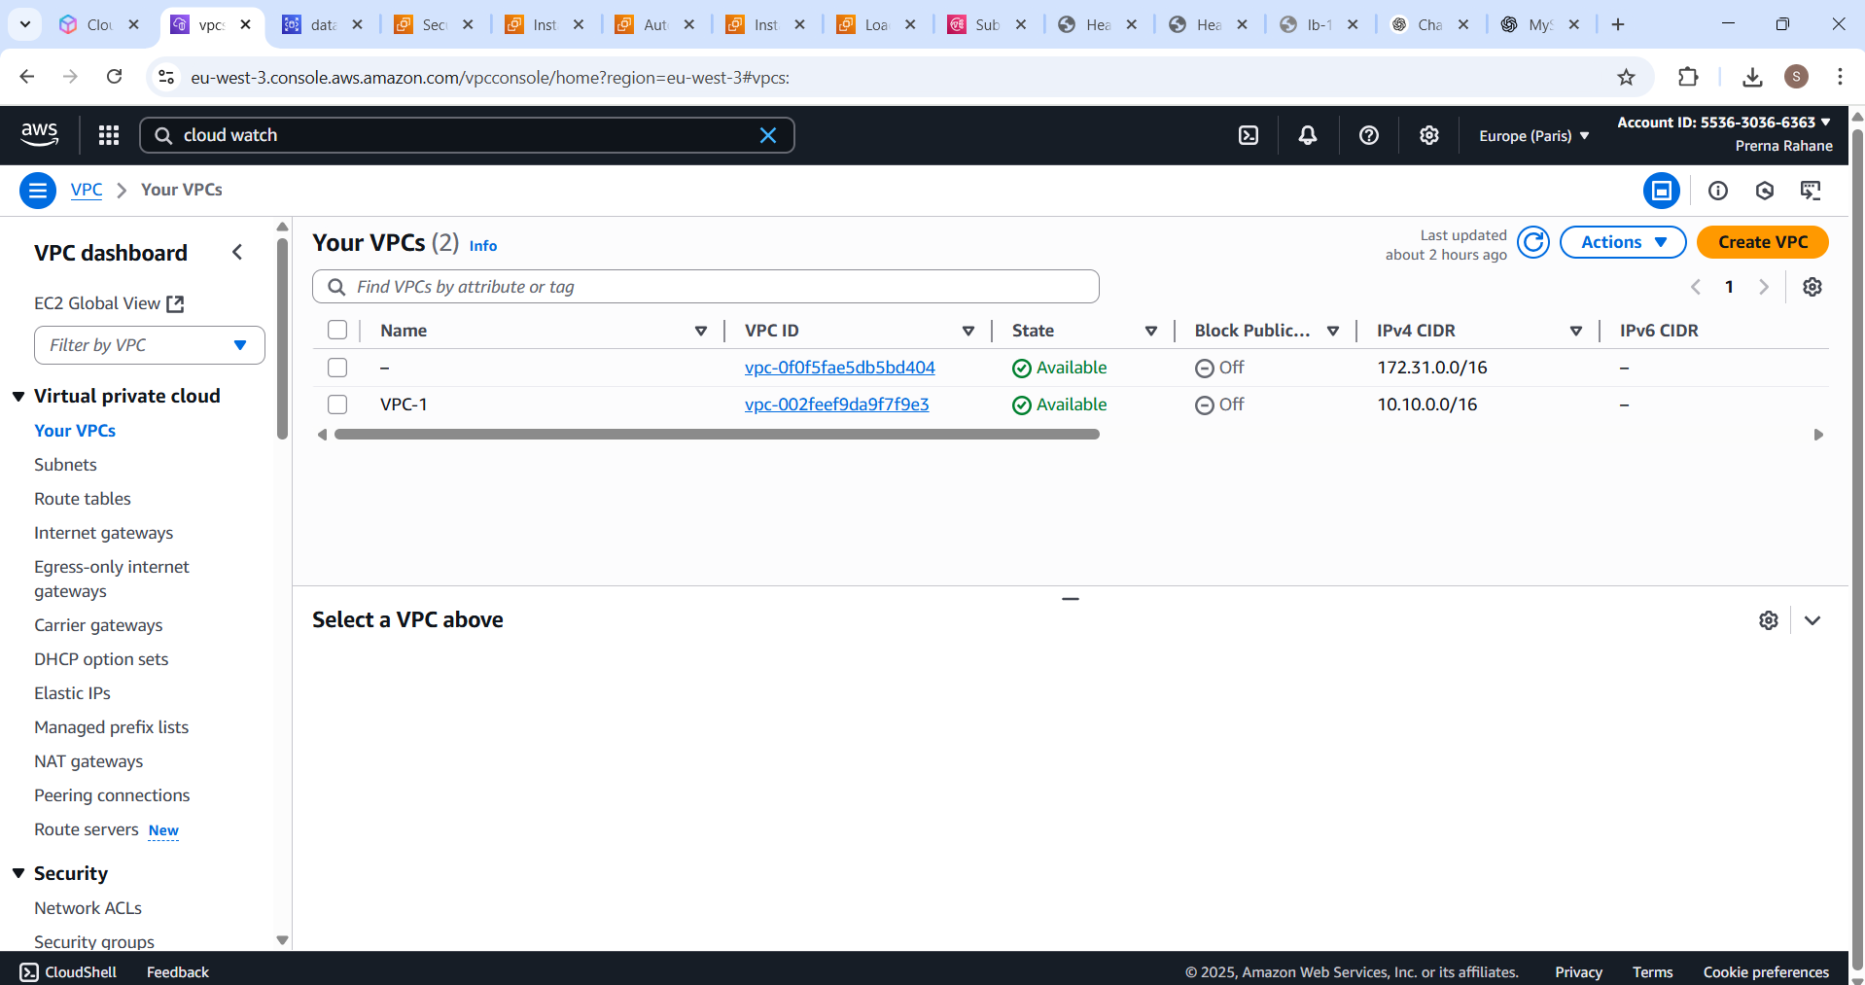
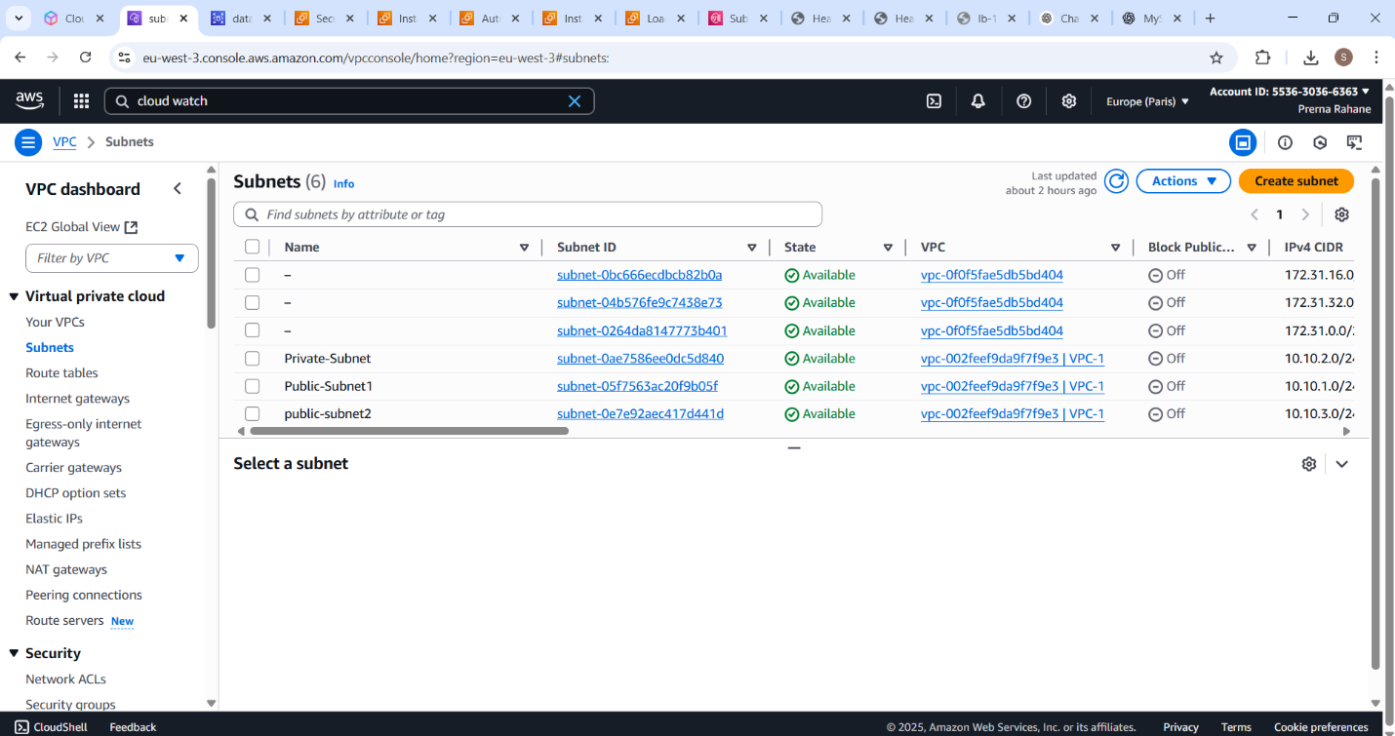

3.SNS Topic and Mail Notification
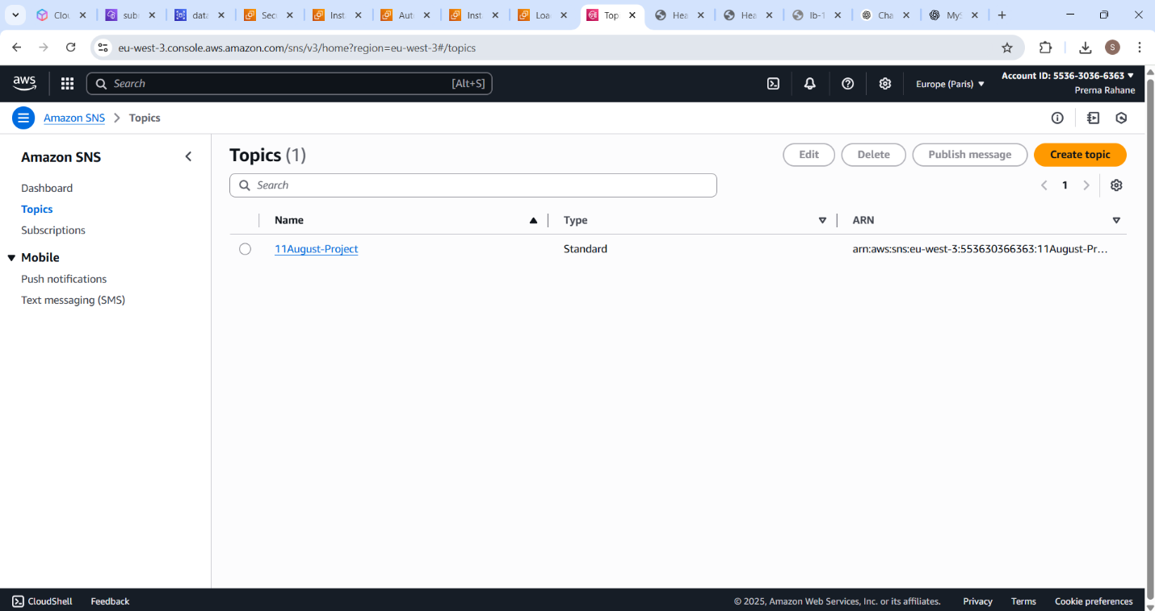
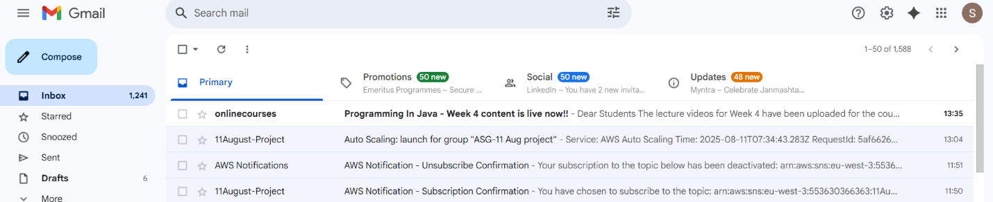

4.Create Load Balancer & Auto Scalling Group
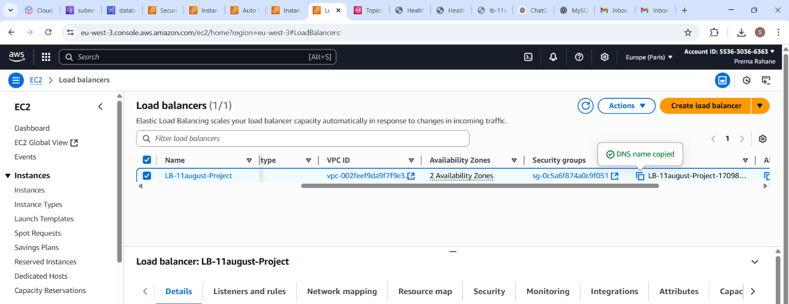

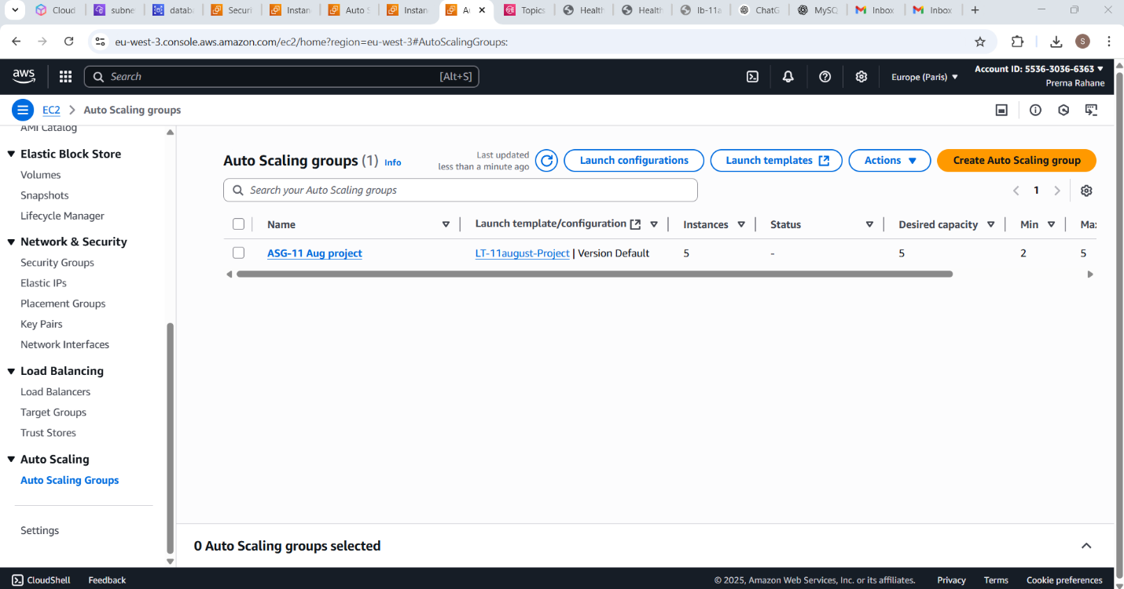
5.Create Database & Cloud Watch Dashboard
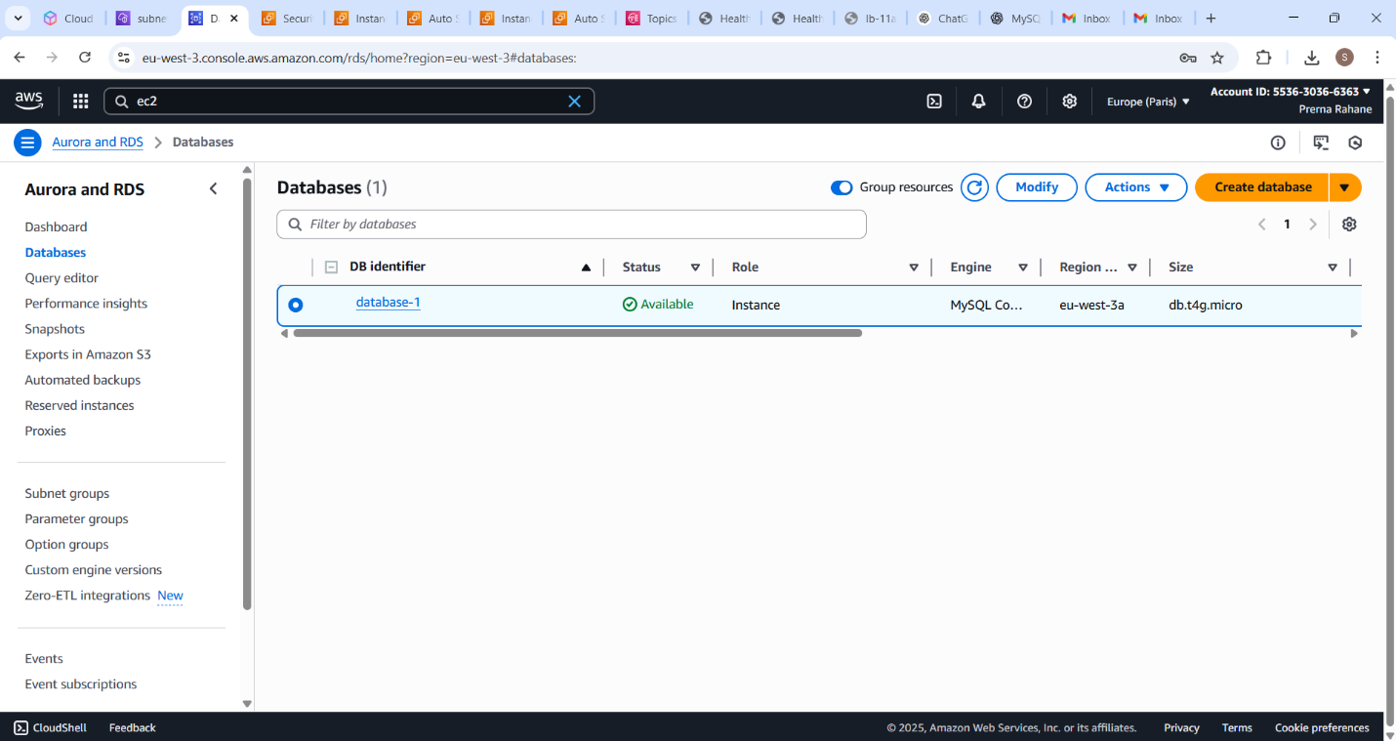

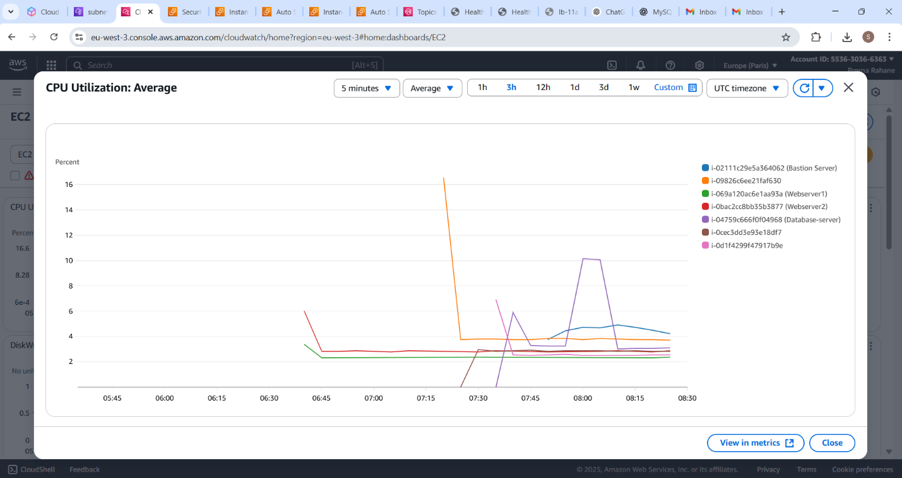

6.Login Database With Bastion Server
